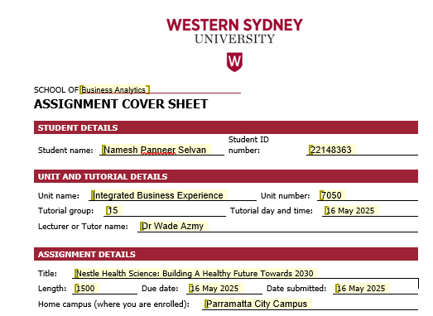
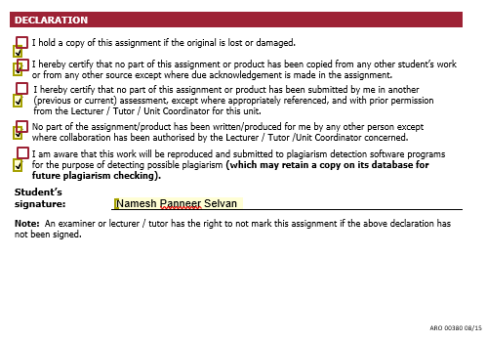

Introduction:

Nestle Health Science – NHSc stands at a critical business crossroads as it plots its direction towards the year 2030. Greg Behar, who led NHSc as CEO of the company, transformed NHSc with an approach of strategic acquisitions, innovative culture, and market expansion, helping to build a strong foundation for the business. As the company now enters a new chapter, it decides to appoint Anna Mohl as their new global CEO, who is the first-ever female global CEO in Nestles history. With her vast experience in the global markets, she inherits a solid footprint in the North American region with a robust portfolio focused on consumer care and medical nutrition. She has a clear mandate to future-proof the company within a volatile market, operational challenges, and increasing consumer demand for sustainable, preventative, and personalised health solutions.

Competitive Landscape:

NHSc is shaped by revolutionary change in global health, wellness trends, and innovation in technology. As a pioneer in the field of nutritional science, NHSc operates within a fast-paced environment which is influenced by multiple forces like changing regulation policy, consumer behaviour trends, advancement in technology and a growing focus on preventative health. To understand the strategic pressures faced by NHSc, we need a framework that offers a structured approach to analyse the market intensity. This analysis is provided through the Porter’s Five Force Framework which explains the competitive rivalry, bargaining powers of buyers & suppliers, threat of new entrants & substitutes. (Michael Porter, Harvard Business Review 2008)

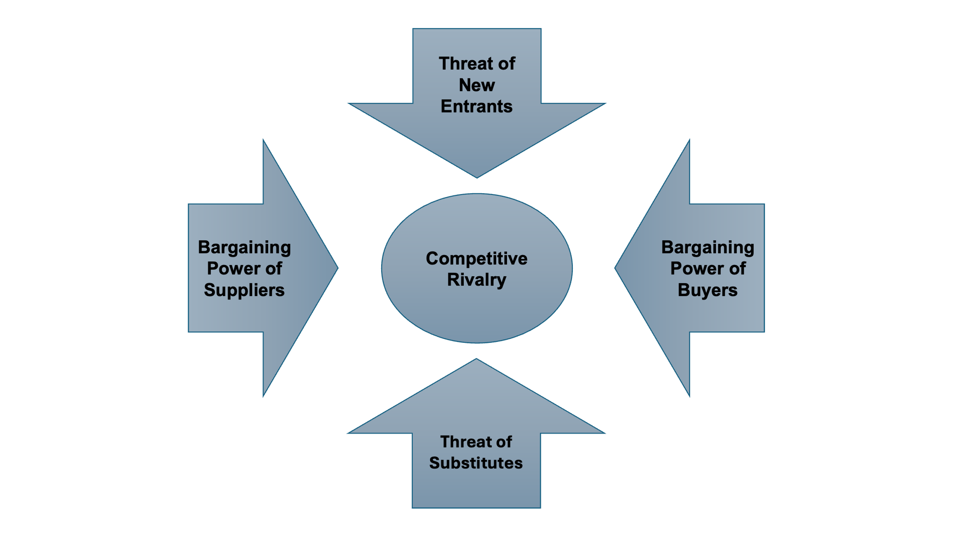

- Competitive Rivalry – The competitive rivalry is a type of force used for measuring the market competition in the existing markets. It measures the trends like price, quality, innovation, and marketing strategies among the rival companies. High rivalry may limit the profitability of the organisation. (Peter Gratton, Investopedia 2025)

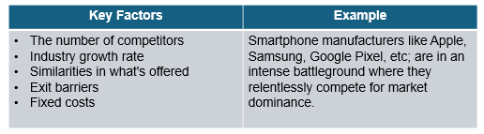

- Threat of New Entrants – This force focuses on an effortless process for onboarding new competitors in the market. The market barriers determine the new entrants. (Renee Ann Butler, Investopedia 2021)

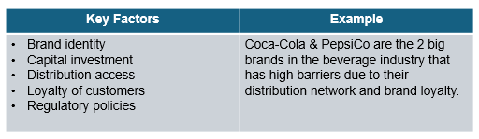

- Bargaining Power of Suppliers – This force focuses on determining the market influencers by identifying companies demanding higher prices, limited quantities, etc., especially when there are few alternative or substitute products available in the market. (Peter Gratton, Investopedia 2025)

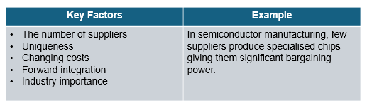

- Bargaining Power of Buyers – This force focuses on the customer strength that can exert pressure on business to provide better quality goods and services at lower prices or may request for additional services. (Laura Blackmore, Cascade 2024)

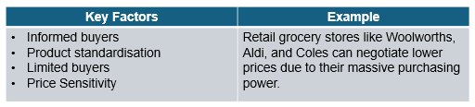

- Threat of Substitutes – This force focuses on the limit of profitability due the availability of substitute products in the market that provides an alternative option to the customers. (Lisa Brown, Panmore Institute 2024)

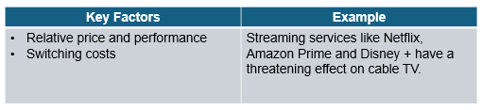

The Poter’s Five Forces framework provides a clear and structured analysis for the competitive landscape of NHSc, that helps them to assess their potential for achieving maximum profit from the market.

New trends & drivers for change:

- Trends for change –

The case study of NHSc – Nestle Health Science explains the robust changes in the market for new trends and the drivers for these changes. The external factors of business, like changing consumer behaviour, command the market's attention by analysing the increase in consumers who prioritise health, fitness, and immunity post-pandemic, which leads to an increase in demand for personalised nutrition and preventative healthcare solutions. With the advancement in technology, specifically in generative AI and digital health, advanced healthcare products and services can be delivered and consumed. This creates an innovative and automotive opportunity for the organisation. The mounting pressure due to a combined effect of inflation, global economics, and a shortage in the healthcare workforce creates a challenging environment that is demanding efficiency and cost-effective results. Moreover, the increasing focus on women’s health and sustainability standards set by the United Nations Sustainable Development Goals are reshaping the corporate approach, encouraging companies like NHSc to align health innovation with sustainability standards. (Elham Pazirandeh-Micol, Karine Richard, Liudmila Ost & Quentin de Rham, Nestle Health Science: Building a Healthy Future Toward 2030 – The Case Study 2025)

- Drivers for change –

Under the new CEO Anna Mohl, NHSc’s internal strategic transformation signifies an important driver of change. Mohl advances Greg Behar's legacy by focusing on individuals with a collaborative leadership style and fostering creative solutions with empowered teams. The company has shifted its focus towards expanding consumer care and medical nutrition, with a strategic exit from pharmaceutical sectors that show slower growth. NHSc is internally optimising its resilient organisational culture, empowered workforce, and inclusive leadership perspective as a foundation to tackle operational disruption and strengthen collaborative efforts across departments for long-term growth. The internal decision to shift focus towards sustainable expansion and advanced customer-oriented development efforts to expand beyond North America further reflects the company’s proactive response towards the external pressure. (Elham Pazirandeh-Micol, Karine Richard, Liudmila Ost & Quentin de Rham, Nestle Health Science: Building a Healthy Future Toward 2030 – The Case Study 2025)

NHSc’s journey towards 2030 is shaped by a dynamic interplay of internal and external factors of the company, compelling leadership to strategically evaluate market trends, streamline investments, and accelerate innovation. (Elham Pazirandeh-Micol, Karine Richard, Liudmila Ost & Quentin de Rham, Nestle Health Science: Building a Healthy Future Toward 2030 – The Case Study 2025

Resources and capabilities:

The foundation of a company’s market superiority depends upon the resources and capabilities that it holds. This empowers the organisation to generate meaningful results, maintain a competitive edge, and build lasting prosperity. (Michael J. Leiblein & Jeffrey J. Reuer, Strategic Management Review 2020)

- Resources – The assets of a company both tangible & intangible in nature are considered as the resources of a company. (Michael J. Leiblein & Jeffrey J. Reuer, Strategic Management Review 2020)

By applying tools like the VRIO framework which is a strategic framework used for analysing an organisations internal resource to assess their potential to contribute to the enduring market strength. VRIO stands for Valuable, Rare, Imitate, and Organise.
(Elham Pazirandeh-Micol, Karine Richard, Liudmila Ost & Quentin de Rham, Nestle Health Science: Building a Healthy Future Toward 2030 – The Case Study 2025)
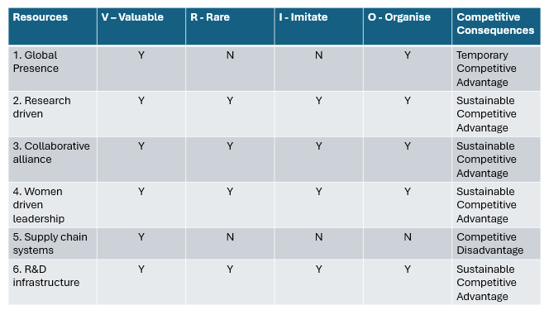

Summary:

- Global Presence – NHSc utilises Nestle’s research but lacks sustainable competitive advantage. (Elham Pazirandeh-Micol, Karine Richard, Liudmila Ost & Quentin de Rham, Nestle Health Science: Building a Healthy Future Toward 2030 – The Case Study 2025)

- Research driven – The company focuses on building rare, valuable difficult to imitate edge. (Elham Pazirandeh-Micol, Karine Richard, Liudmila Ost & Quentin de Rham, Nestle Health Science: Building a Healthy Future Toward 2030 – The Case Study 2025)

- Collaborative alliance – It strategically focuses on rare and complex innovations. (Elham Pazirandeh-Micol, Karine Richard, Liudmila Ost & Quentin de Rham, Nestle Health Science: Building a Healthy Future Toward 2030 – The Case Study 2025)

- Women driven leadership – The leadership of the new CEO Anna Mohl promotes rare, inclusive culture which is difficult to replicate. (Elham Pazirandeh-Micol, Karine Richard, Liudmila Ost & Quentin de Rham, Nestle Health Science: Building a Healthy Future Toward 2030 – The Case Study 2025)

- Supply chain systems – Disruption in supply chain due to system integration weakens the company’s competitive position. (Elham Pazirandeh-Micol, Karine Richard, Liudmila Ost & Quentin de Rham, Nestle Health Science: Building a Healthy Future Toward 2030 – The Case Study 2025)

- R&D infrastructure – The establishment of technology center in Bridgewater (USA) builds rare, inimitable edge in the company’s innovation. (Elham Pazirandeh-Micol, Karine Richard, Liudmila Ost & Quentin de Rham, Nestle Health Science: Building a Healthy Future Toward 2030 – The Case Study 2025)

- Capabilities – Capabilities are the skills used by an organisation to leverage these resources. With the recent shift towards dynamic capabilities like adaptability, innovation and learning which is essential for digital disruption and sustainability demands. (Michael J. Leiblein & Jeffrey J. Reuer, Strategic Management Review 2020)

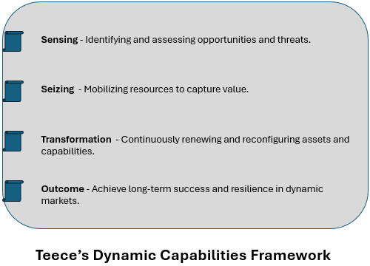

Summary:

The Teece’s Dynamic framework effectively analysis the internal capabilities and culture of NHSc in order to maintain the strategic flexibility to ensure the growth in the evolving health science industry. (Elham Pazirandeh-Micol, Karine Richard, Liudmila Ost & Quentin de Rham, Nestle Health Science: Building a Healthy Future Toward 2030 – The Case Study 2025)

Growth Strategy:

Given that the business can grow by developing new products in the same markets or by taking existing products to new markets to diversify the business. This can be explained by using Ansoff Growth Matrix framework.
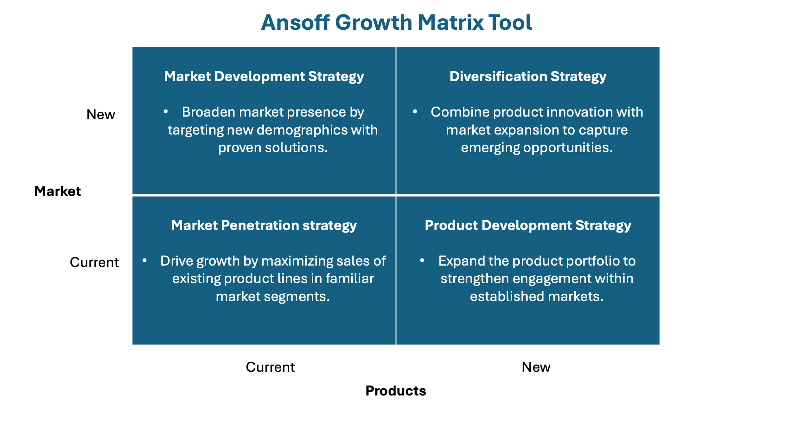
Sustainability and social responsibility:

NHSc has aligned sustainability and social responsibility into its strategy. By 2025 the company is planning to achieve 100% renewable electricity in all its operational activities and reduce its carbon emissions. The company is promoting participatory leadership with its French arm designated as a “Mission-Driven Company”. The efforts taken by NHSc towards environment creates an ethical business practice in the market. (Hoboken N.J, Nestle Health Science USA 2024)

Innovation (Exploration & Exploitation):

NHSc has a dual-focus approach that focuses on exploration and exploitation in the market. As per the ambidexterity theory of innovation, which is to maintain a balance between long-term exploration and short-term exploitation, the company enables itself to remain competitive in both established and emerging markets.

- Exploration – The company drives innovation by investing in research and collaborating with life science innovators. NHSc developed VOWST under partnership; this was the first FDA-approved oral microbiota treatment. The company also explores women’s health and clinical science. (Elham Pazirandeh-Micol, Karine Richard, Liudmila Ost & Quentin de Rham, Nestle Health Science: Building a Healthy Future Toward 2030 – The Case Study 2025)

- Exploitation – NHSc enhances its performance by optimising and expanding already existing products. This helps them to expand Orgain and Boost in North America. Focusing on consumer care and medical nutrition, the company elevates its stability for long-term growth. (Nestle 2024)

Reference List:

Blackmore, L 2024, ‘Porter’s Five Forces: Complete Guide, Examples & Template’, Cascade, viewed 16 may 2025, < www.cascade.app/blog/porters-5-forces >
Brown, L 2024, ‘Netflix Five Forces Analysis & Recommendations (Porter’s Model)’, Panmore Institute, 20 November, viewed 16 May 2025, <panmore.com/netflix-five-forces-analysis-recommendations-porters case-study>

Butler, R.A 2021, ‘How Coca-Cola Stacks up against New Entrants’, Investopedia, 16 September, viewed 16 May 2025, < www.investopedia.com/articles/markets/120915/analyzing-porters-5-forces-cocacola.asp>

Gratton, P 2025, ‘Porter’s Five Forces Explained and How to Use the Model’, Investopedia, 28 March, viewed 16 May 2025, <www.investopedia.com/terms/p/porter.asp>

Leiblein M.J & Jeffrey J.R 2020, ‘Foundations and Futures of Strategic Management’, Strategic Management Review, 4 March, viewed 16 May 2025, < www.nowpublishers.com/article/Details/SMR-0001>

Hoboken, N.J 2024, ‘Nestlé Health Science USA.” Nestlé Health Science USA’, Nestle Health Science, 4 April, viewed 16 May 2025, < www.nestlehealthscience.us/stories/nestle-health-science-recognized-us-department-energy-sustainability-efforts >

Nestle 2024, ‘Nestle Annual Report’, Nestle.com, viewed 16 May 2025, <www.nestle.com/investors/annual-report >

Pazirandeh-Micol, E., Richard, K., Ost, L. & de Rham, Q. 2025, Nestle Health Science: Building a Healthy Future Toward 2030, IMD – International Institute for Management Development, viewed 16 May 2025, <vUWS course site [Restricted Access]>

Porter, M 2008, ‘The Five Competitive Forces That Shape Strategy’, Harvard Business Review, Viewed 16 May 2025, < hbr.org/2008/01/the-five-competitive-forces-that-shape-strategy >

